// assignment 9

// Guo Hong

// guohong

// Zhao Haonan

// haonan

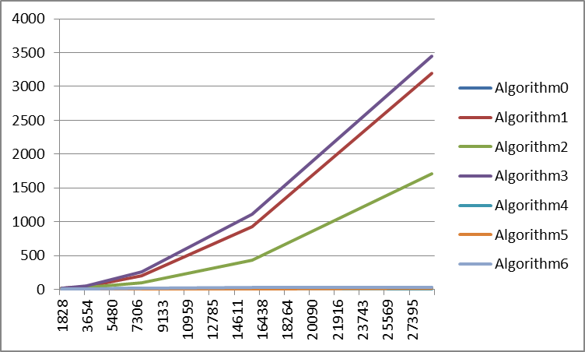

The main finding of this sorting detective tests is that different algorithms can have very different running time. The algorithm 0, 4 and 5 run fastest and algorithms 1 and 3 are the slowest one. The running time of algorithm 2 is between the fastest and slowest but not significant faster than the slowest (1 and 3), which may indicates algorithm 2 is similar to algorithm 1 and 3 but with better implementation. Based on chart, we can see that 0, 4, 5 are the fastest algorithms, so they might run in O(n.log_n) time. Algorithm 1, 2, 3 run much slower, so they are mostly in quadratic time, i.e. O(n^2). The algorithm 1 and 4 have stack over flow error, which usually means there are too many recursive calls in these algorithms, when the input is very big, they will have stack over flow problems. The running time for selection sort is O(n^2). From our analysis above, it is most likely that algorithm 3 is selection sort because it is slowest. We also find that there is a difference in running time between different comparators, which indicate the time needed for each comparison is different for different comparators. The algorithm 6 is heapsort, which we know runs in O(n.log_n) time. Algorithm 0, 4, 5 have similar running time as algorithm 6, further confirm their running time.

Which algorithms run mostly in quadratic time, i.e. O(n^2)?

1, 2, 3

Which algorithms run mostly in O(n.log_n) time?

0, 4, 5

Which algorithms use the functional style, using Cons lists?

1, 4

Which algorithm is the selection sort?

3

Why is there a difference when the algorithms use a different Comparator?

For Strings, the comparator will compare the character in string one by one, so it is the slowest.

The double type has two part, the integer part and the decimal part. The comparator will compare these two parts, so the running time is intermediate between integer and strings.

The integer comparator can compare integers through one comparison, so it is fastest.